1) Install Jenkins and run Jenkins on port number 8081
OVERVIEW (Amazon Linux Setup)
You will:
- Launch EC2 (Amazon Linux)
- Install Jenkins on port 8081
- Secure Jenkins
- Create users & roles
- Configure labels
- Create jobs
- Connect private GitHub repo

STEP 0: Launch EC2 Instance (Amazon Linux)
🔹 Why?
Jenkins runs on a server → here we use AWS EC2

Launch Instance
- Go to AWS Console → EC2
- Click Launch Instance
Select:
- AMI → Amazon Linux 2 / Amazon Linux 2023
- Instance type → t2.micro (free tier)
- Key pair → create/download
- Security Group → Allow:
  - SSH (22)
  - Custom TCP → 8081
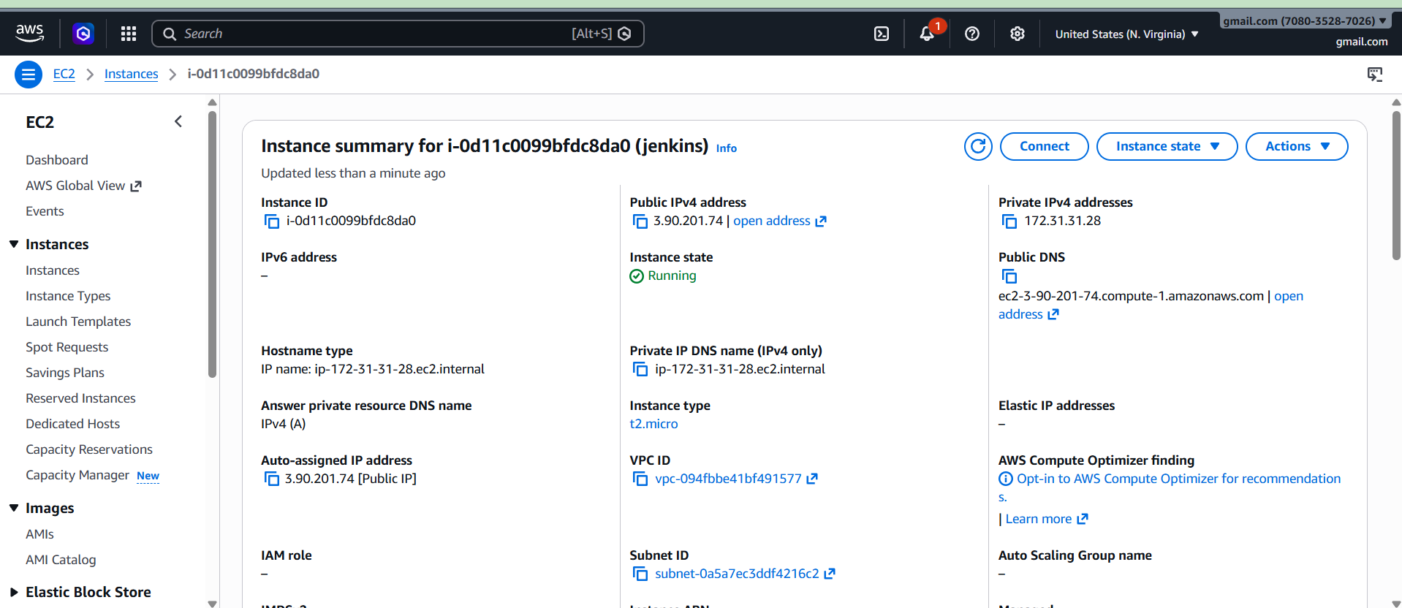

Connect to EC2
ssh -i your-key.pem ec2-user@<public-ip>

STEP 1: Install Jenkins on Amazon Linux
🔹 1.1 Install Java
Jenkins requires Java
sudo yum update -y
sudo yum install java-17-amazon-corretto -y
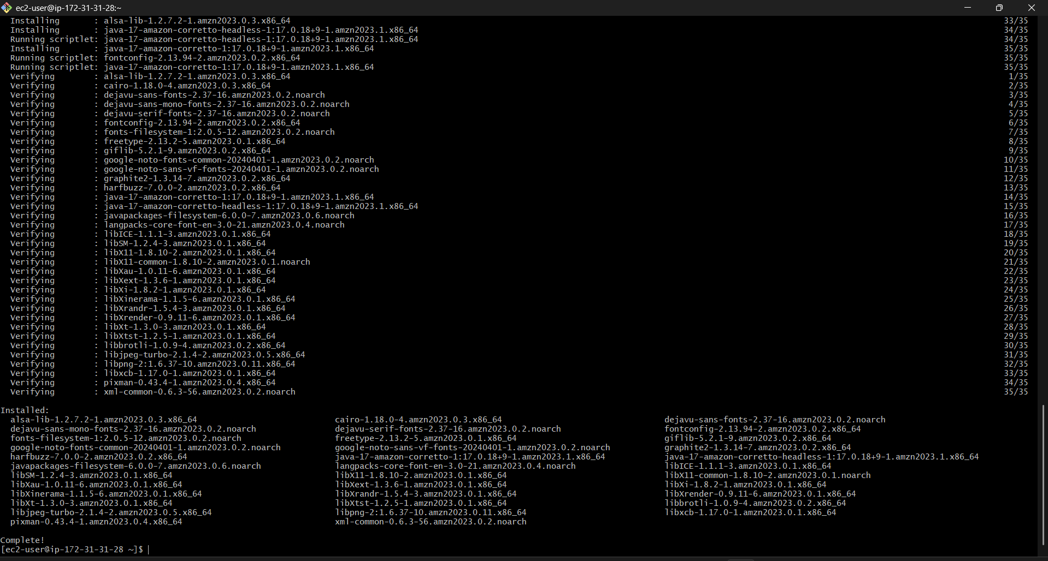
Check:
java -version
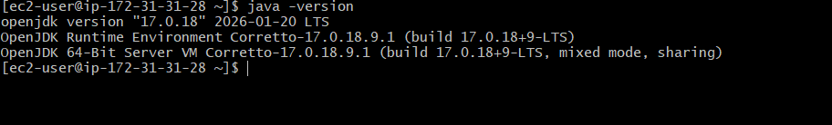

🔹 1.2 Install Jenkins
sudo wget -O /etc/yum.repos.d/jenkins.repo \
https://pkg.jenkins.io/redhat-stable/jenkins.repo
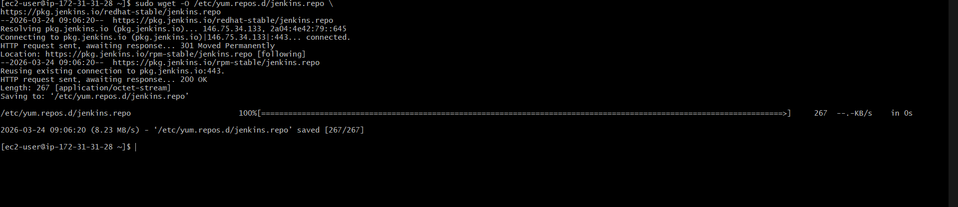
sudo rpm --import https://pkg.jenkins.io/redhat-stable/jenkins.io.key
sudo yum install jenkins -y
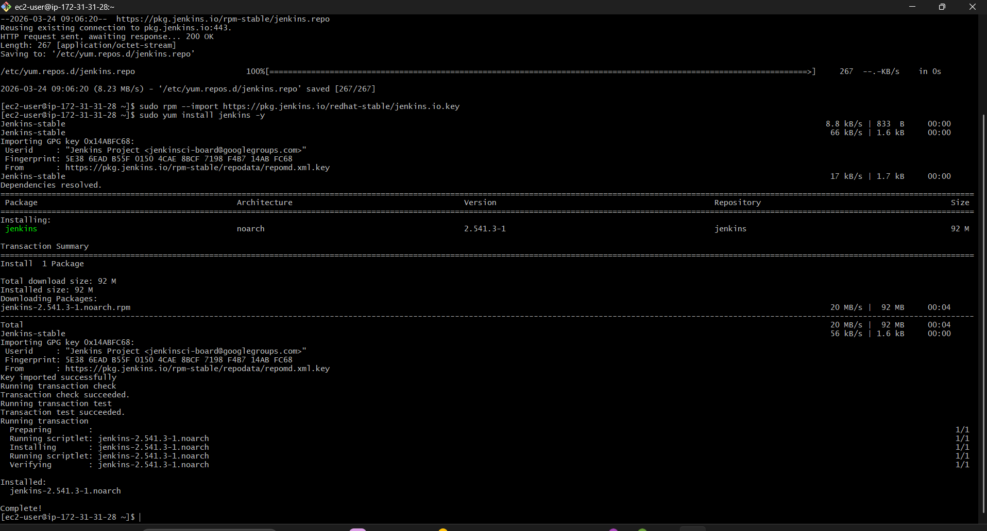

🔹 1.3 Change Port (8080 → 8081)
Important for your question
sudo vi /usr/lib/systemd/system/jenkins.service
Change:
JENKINS_PORT="8081"


🔹 1.4 Start Jenkins
sudo systemctl start jenkins
sudo systemctl enable Jenkins
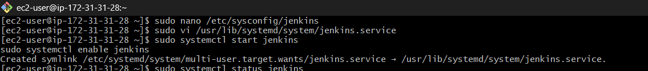
Check:
sudo systemctl status Jenkins
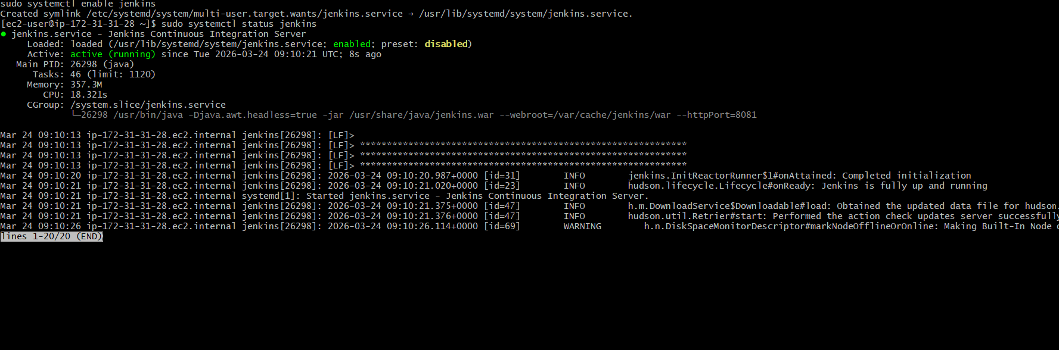

🔹 1.5 Open Jenkins in Browser
http://<EC2-PUBLIC-IP>:8081

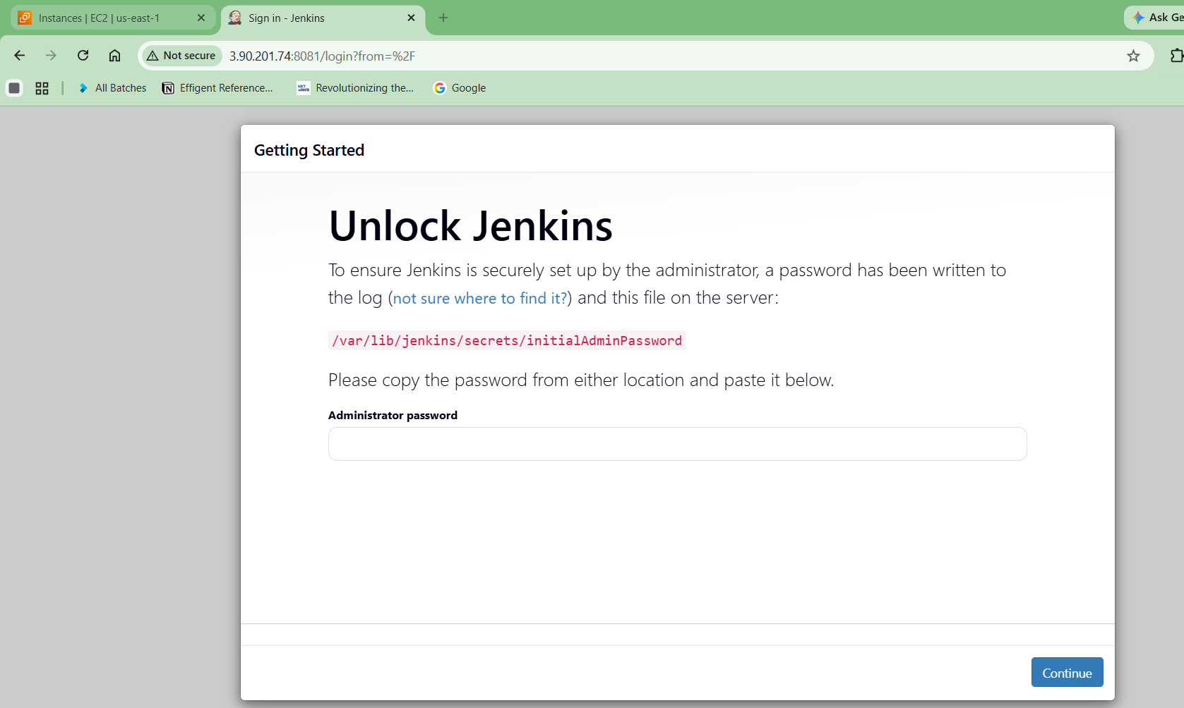

Get password:
sudo cat /var/lib/jenkins/secrets/initialAdminPassword

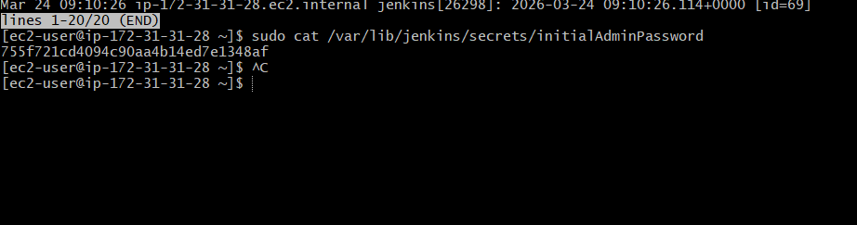

2: Secure Jenkins Server
🔹 Why?
Prevent unauthorized access

Install Plugins
Click:
Install Suggested Plugins

Create Admin User
Fill:
- Username
- Password
Never use default admin
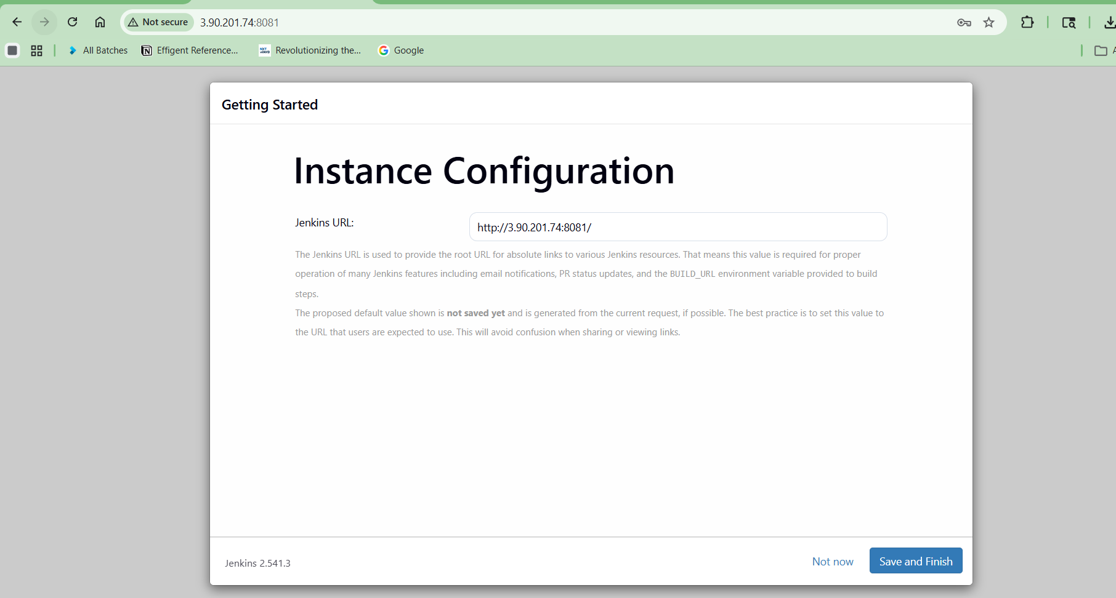

Enable Security
Go:
Manage Jenkins → Configure Global Security
Enable:
✔ Role-Based Strategy

🔹 STEP 1: Install Plugin (if not already)
Go:
Manage Jenkins → Manage Plugins → Available
Search:
Role-based Authorization Strategy
✔ Tick it → Click:
Install without restart

🔹 STEP 2: Open Security Settings
Go:
Manage Jenkins → Configure Global Security

🔹 STEP 3: Enable Security Options
✔ Authentication
Select:
Jenkins’ own user database

✔ Authorization (MAIN STEP )
Scroll to Authorization section
Select:
Role-Based Strategy
This option appears ONLY after plugin installed

🔹 STEP 4: Save Settings
Click:
✔ Apply
✔ Save

🔧 STEP 5: Configure Roles (Very Important)
Now go:
Manage Jenkins → Manage and Assign Roles

A. Manage Roles
Click:
Manage Roles
Create roles like:
🔹 admin
✔ Overall → ALL permissions
🔹 developer
✔ Job → Read, Build
❌ No admin access
🔹 viewer
✔ Only Read
B. Assign Roles
Click:
Assign Roles
Now map users:
User | Role
your_user | admin
dev_user | developer
guest | viewer

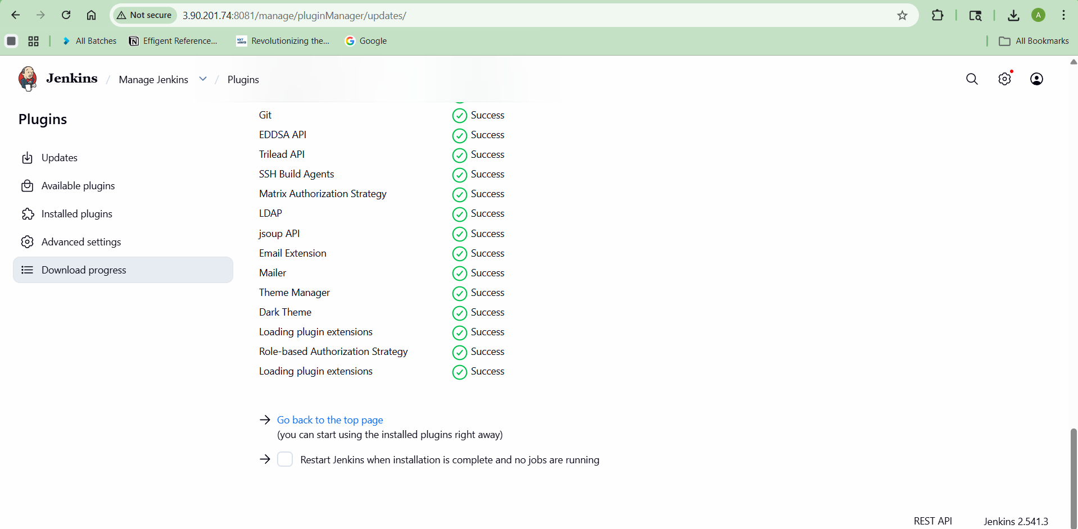
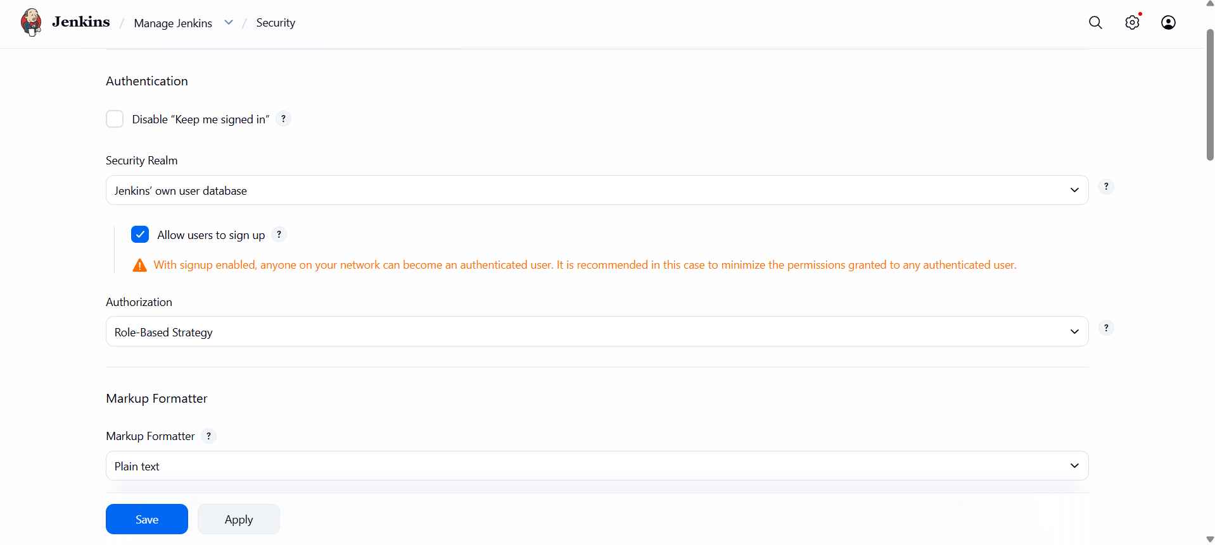
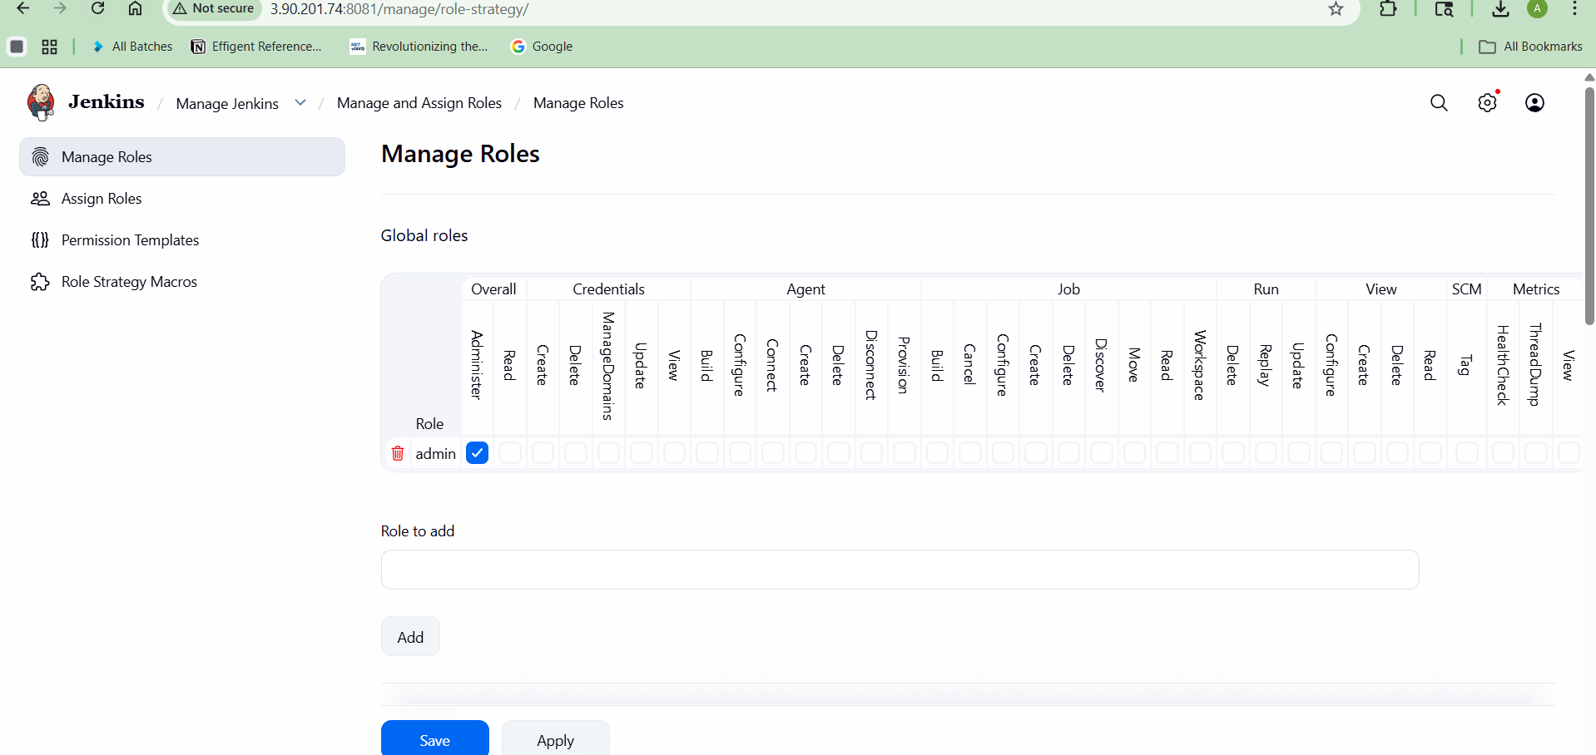

3 Create users called DevOps, Testing in Jenkins with Limited access
🔹 Why this step?
In real companies:
- DevOps → full control
- Tester → limited access

3.1 Install Role Plugin
Manage Jenkins → Plugins → Install:
Role-based Authorization Strategy

3.2 Create Roles
Go:
Manage Jenkins → Manage and Assign Roles → Manage Roles
Create:
🔸 DevOps Role
✔ Full permissions:
- Job create
- Build
- Configure
- Delete

🔸 Testing Role
✔ Limited:
- Read
- Build only

3.3 Create Users
Manage Jenkins → Manage Users → Create User
Create:
- devops_user
- testing_user

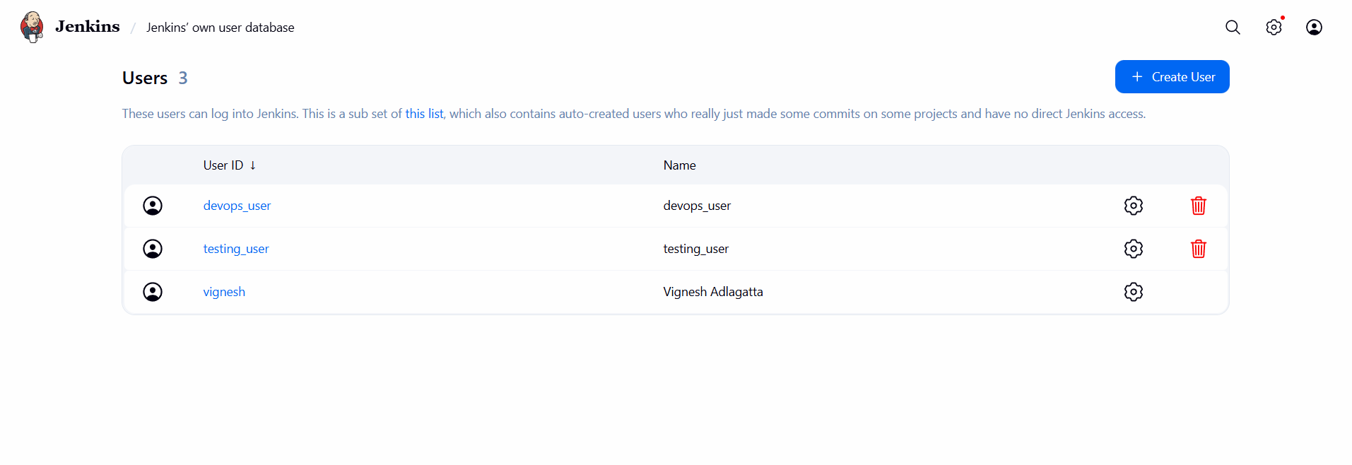

3.4 Assign Roles
Assign Roles → Map users
devops_user → DevOps role
testing_user → Testing role
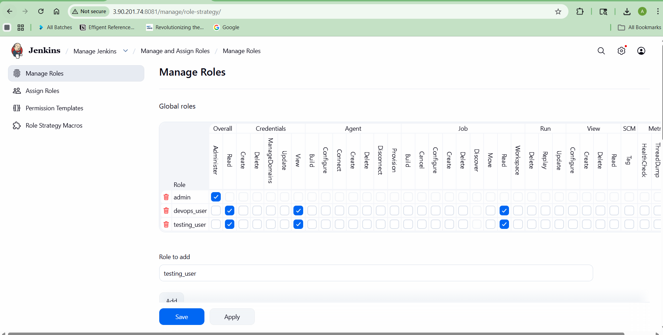

4) Configure labels and restrict the jobs to execute based on label only
🔹 Why this step?
Labels = control where jobs run
Example:
- Dev jobs → dev server
- Prod jobs → prod server

Step 4.1: Add Label to Node
🔧 Steps:
- Go to:
Manage Jenkins → Nodes
- Click on:
Built-in Node (or your agent)
- Click:
Configure
- Find:
Labels
- Add:
dev-server
- Click:
Save

What just happened?
You told Jenkins:
"This node is a dev server"

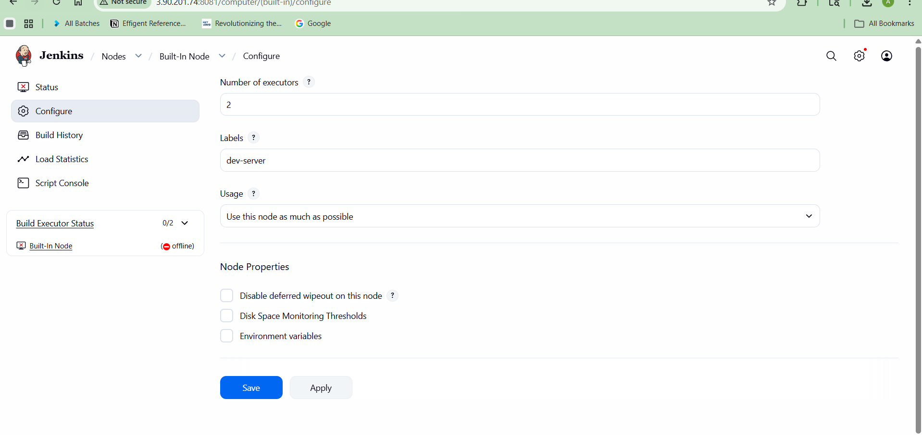

Step 4.2: Restrict Job to That Label
Steps:
- Go to:
New Item → Create Job
- Scroll down to:
General section
- Enable:
✔Restrict where this project can run
- Enter label: dev-server
- Save job

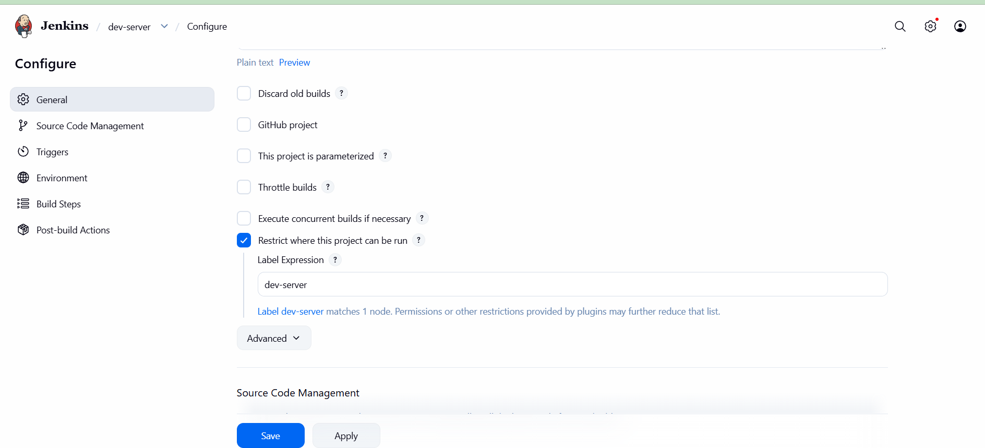

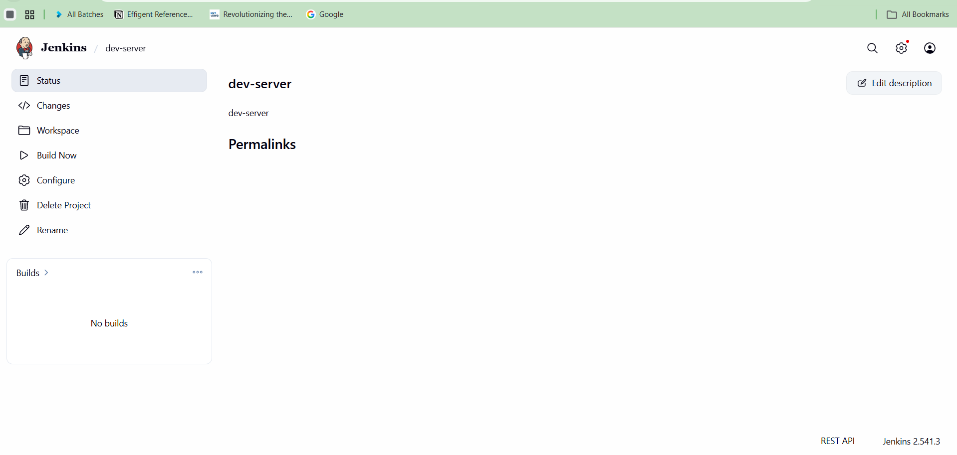

Now job runs ONLY on that node

5) Create Three sample jobs using the below URL
🔹 Why?
Simulate CI/CD pipeline

Job 1: Build Job
New Item → Freestyle → build-job
Git Repo:
https://github.com/betawins/Techie_horizon_Login_app.git
Build Step:
echo "Building app..."
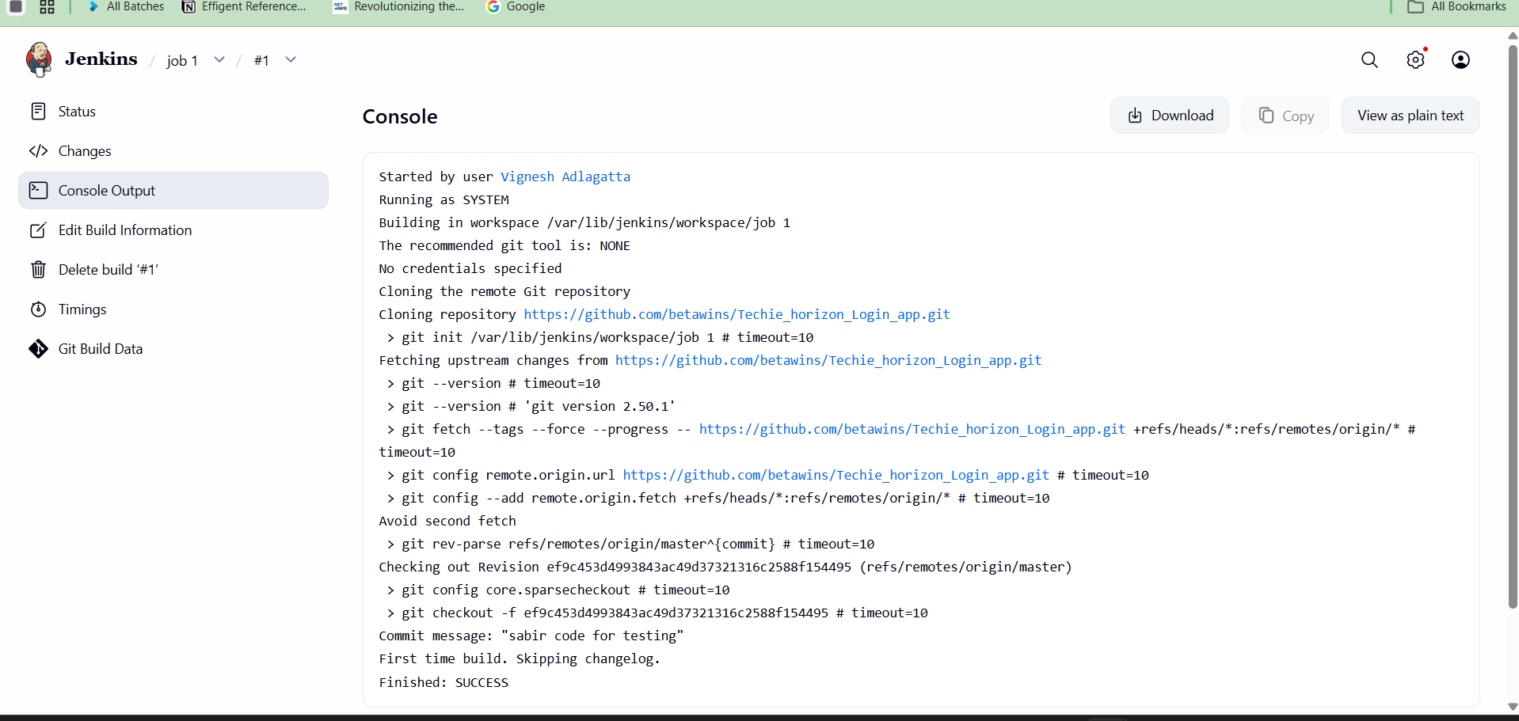
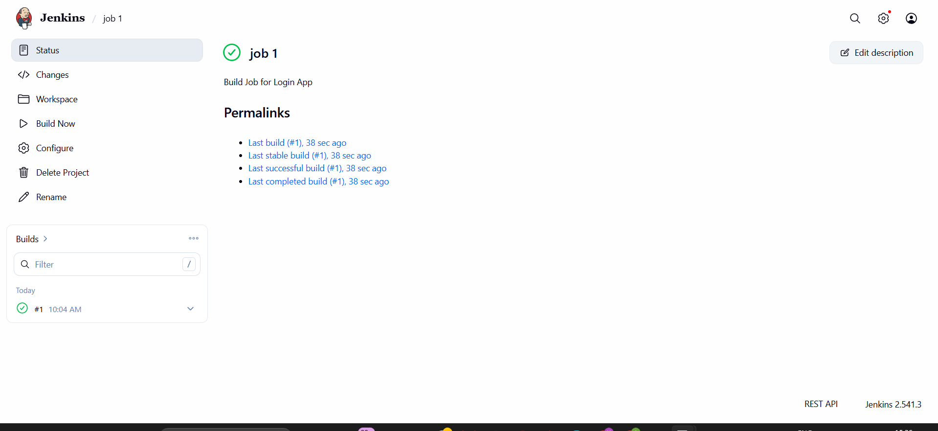

Job 2: Test Job
echo "Running tests..."
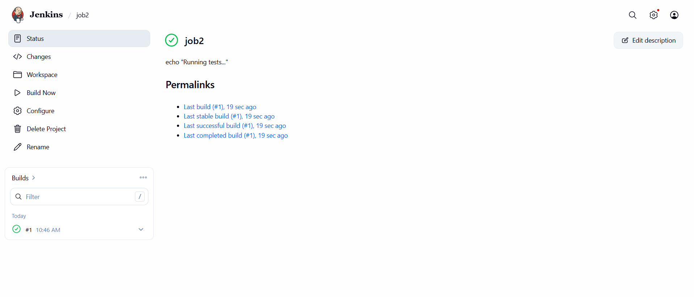
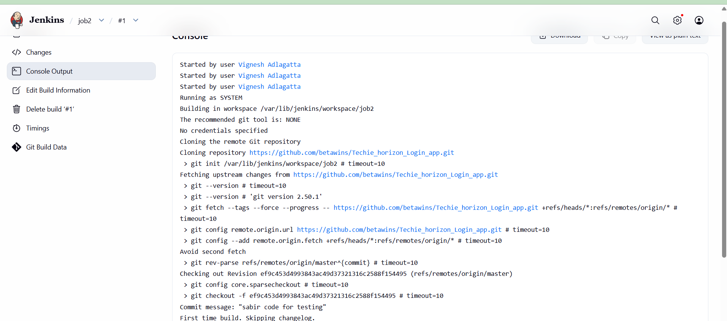

Job 3: Deploy Job
echo "Deploying app..."
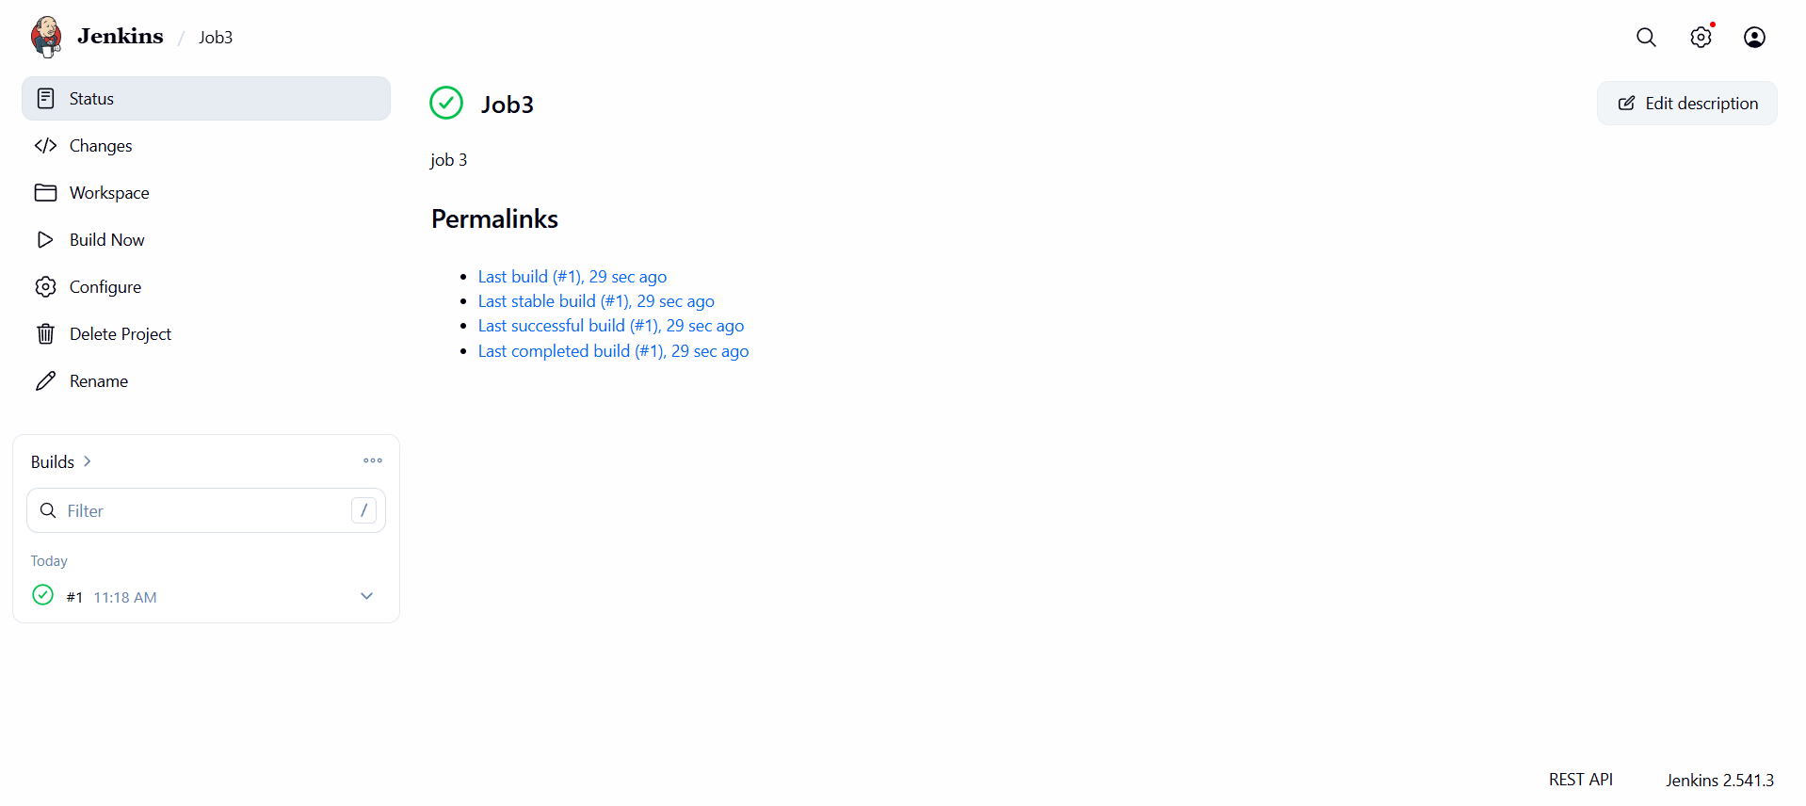
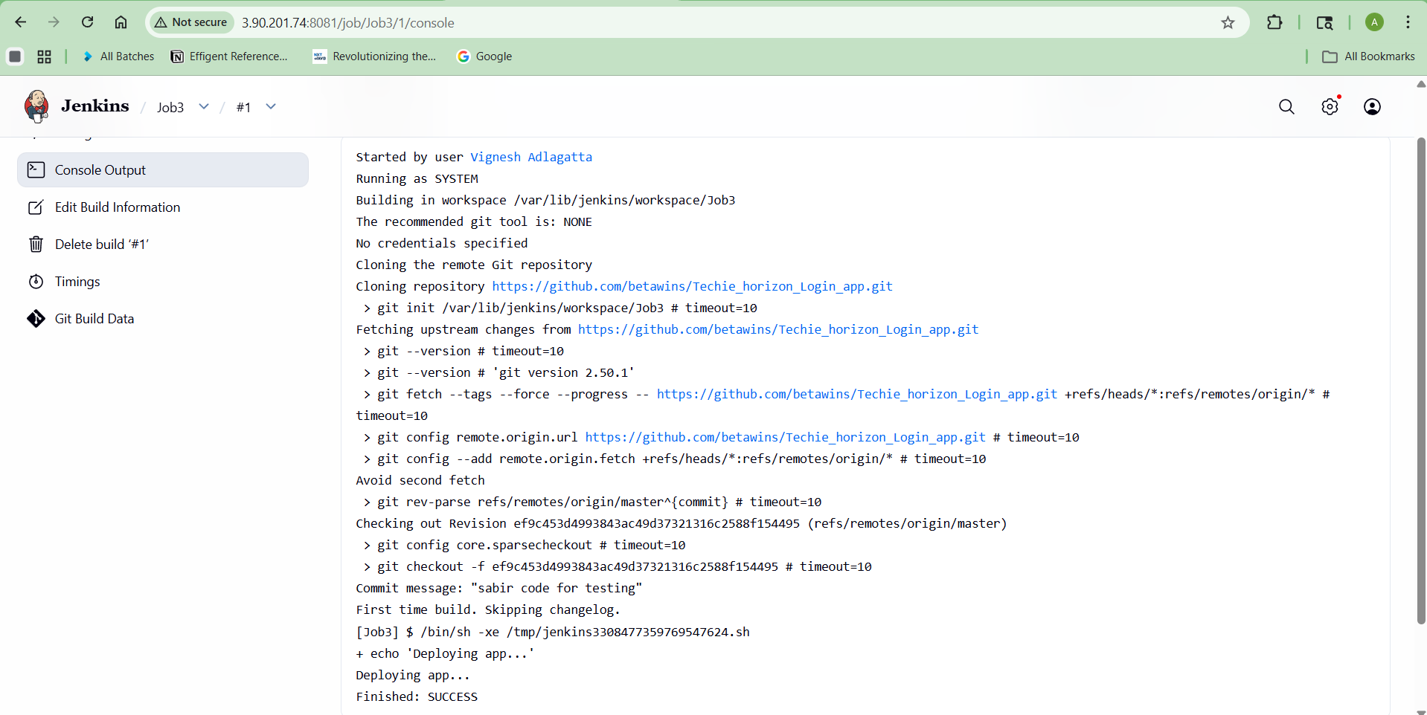
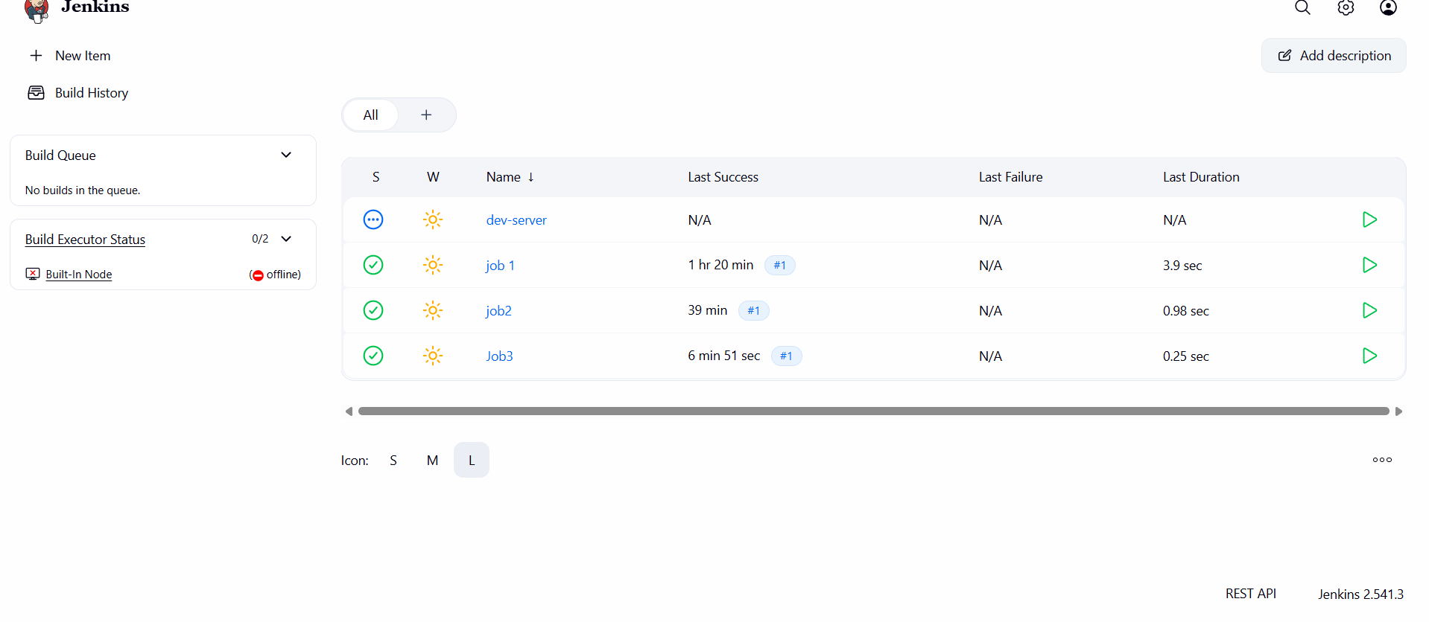

6) Private GitHub Repo Job
Source Code: https://github.com/betawins/Techie_horizon_Login_app.git

7.Create one Jenkins job using GitHub Private repository
Generate Token in GitHub
Go to:
GitHub → Settings → Developer Settings → Personal Access Token

Add Credentials in Jenkins
Manage Jenkins → Credentials → Add Credentials
Type:
- Username + Token

Create Job Using Private Repo
New Item → private-job
Add:
- Git URL
- Credentials (select token)

Screenshot:
- Credentials added
- Successful build
